Mr. Sabado, Algebra 2 Week 6 Monday, September 26, 2016

Homework

Due Today:
- Assignment #21
1.7: Absolute Value Worksheet

Due 9/27
- Assignment #22
p. 56: 41-42, 43-63 odd

Quiz on Friday!!!


Agenda

- Opener Sheet
- Warm-Up

- Lesson: Solving Absolute Values (Extraneous Solutions)

- Class Work

- Homework

Warm-Up

Solve the Following
- 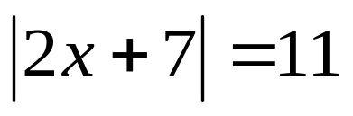
- 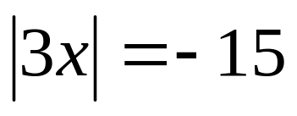
Solve and Graph
- 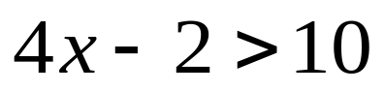
Algebra 2 Online Textbook: 2606518-10
classzone.com

whs.saba.do

Reminder: The bell does not dismiss you, I dismiss you.
- Mr. Sabado

