Mr. Sabado, Algebra 2 Week 6 Friday, September 30, 2016

Homework

Due Today:
- Assignment #25
Rational Exponents Worksheet

Due 10/3
- Assignment #26
Exponents Review Worksheet

Quiz on Friday!!!


Agenda

- Warm-Up
- HW Questions
- Turn in Opener Packet

- Quiz: Solving and Rational Exponents

- Quiet Activity
- Homework



Warm-Up

Solve and check for extraneous
- 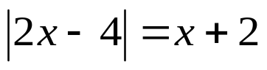

- Simplify the Expression
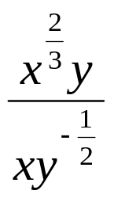
Algebra 2 Online Textbook: 2606518-10
classzone.com

whs.saba.do

whs.saba.do

Reminder: The bell does not dismiss you, I dismiss you.
- Mr. Sabado

