Mr. Sabado, Algebra 1 Week 8 Monday, October 20, 2014

Homework

Due Today:
- Assignment #29:
Mixed Review Worksheet

Due 10/21:
- Assignment #30:
The Cover Method Worksheet

Bring your Textbook every day!!!

Agenda

- Pick Up Opener Sheet
- Warm-Up
- HW Questions

- Lesson Exploration: Equivalent Equations

- Class work
- Homework
- Return Graded Work



Warm-Up

Solve each equation

- 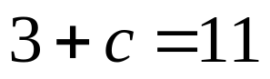

- 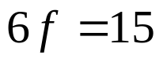

- 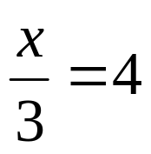

whs.saba.do

“It is never too late to be what you might have been.”
- G. Eliot

