Mr. Sabado, Math 3 Week 8 Monday, October 10, 2017

Homework

Due Today:
- Assignment #29
Cumulative Review

Due 10/11:
- Assignment #30
Cumulative Review

Agenda

- Warm-Up

- Discovery Class Work: Literal Equations
- Homework
- Exit Ticket
- Return Graded Work

Warm-Up

Solve
- 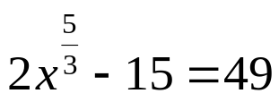

- 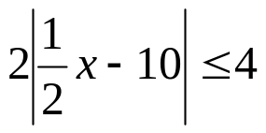

- 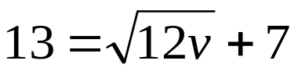


whs.saba.do

“It is never too late to be what you might have been.”
- G. Eliot

