Mr. Sabado, Math 3 Week 8 Wednesday, October 11, 2017

Homework

Due Today:
- Assignment #30
Solving Literal Equations

Due 10/12:
- Assignment #31
Solving Equations

Agenda

- Enter Ticket

- Warm-Up
- HW Check

- Choose Your Fate: Solving Equations
- Homework
- Return Graded Work

Warm-Up

Solve the Following

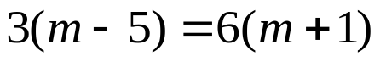
Isolate for y
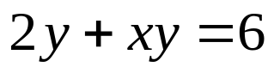


whs.saba.do

“It is never too late to be what you might have been.”
- G. Eliot

