Mr. Sabado, Math 3 Week 9 Monday, October 16, 2017

Homework

Due Today:
- Assignment #33
Solving Task

Due 10/17:
- Assignment #34
Function Operations



Agenda

- Warm-Up

- Class Notes: Function Operations
- Class Work
- Homework
- Return Graded Work

Warm-Up

Let f(x) = 3x and g(x) = x + 3

- 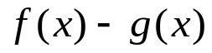
- 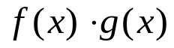

whs.saba.do

“It is never too late to be what you might have been.”
- G. Eliot

