Mr. Sabado, Math 3 Week 7 Monday, October 2, 2017

Homework

Due Today:
- Assignment #24
Choose Your Method

Due 10/2:
- Assignment #25
Solving Absolute Value Inequalities

Quiz on Thursday 10/5!!!

Agenda

- Warm-Up

- Notes: Solving Absolute Value

- Group Class Work
- Homework
- 

Warm-Up

Solve the Following
- 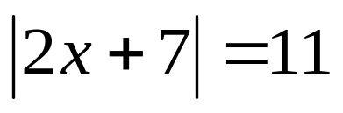
- 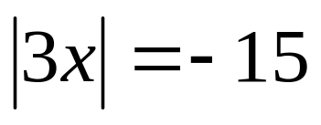

Solve and Graph
3) 

whs.saba.do

“It is never too late to be what you might have been.”
- G. Eliot

