Mr. Sabado, Math 3 Week 10 Friday, October 27, 2017

Homework

Due Today:
- Assignment #41
What is a Polynomial?

Due 10/30:
- Assignment #42
Factoring Polynomials



Agenda

- Warm-Up

- Lesson: Factoring Polynomials

- Class Work

- Homework

- Return Graded Work

Warm-Up

Evaluate the following using synthetic substitution

- 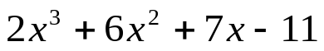 when x = - 8

- 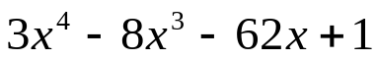 when x = 4


whs.saba.do

“It is never too late to be what you might have been.”
- G. Eliot

