Mr. Sabado, Math 3 Week 7 Tuesday, October 3, 2017

Homework

Due Today:
- Assignment #25
Solving Absolute Value Inequalities

Due 10/4:
- Assignment #26
Unit 2 Practice #1

Quiz on Thursday 10/5!!!

Agenda

- Warm-Up

- Notes: Solving Equations with Whole and Rational Exponents

- Class Work
- Homework
- 

Warm-Up

Solve and graph
- 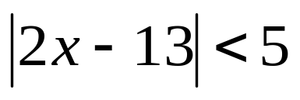
Simplify

- 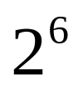

3) 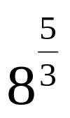
whs.saba.do

“It is never too late to be what you might have been.”
- G. Eliot

