Mr. Sabado, Math 3 Week 7 Thursday, October 5, 2017

Homework

Due Today:
- Assignment #27
Unit 2 Practice #1

Due 10/6:
- Assignment #28
Quiz Review

Quiz on Friday 10/6!!!

Agenda

- Warm-Up
- HW Check

- Complete: Scavenger Hunt

- Class Work
- Homework
- Return Graded Work

Warm-Up

Solve and graph the following

- 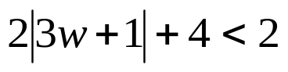
Solve
- 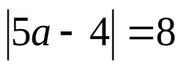

whs.saba.do

“It is never too late to be what you might have been.”
- G. Eliot

