Mr. Sabado, Math 3 Week 13 Tuesday, November 14, 2017

Homework

Due Today:
- Assignment #51
Rational Zero Theorem

Due 11/15:
- Assignment #52
Rational Zero Theorem 2



Agenda

- Warm-Up

- Lesson: Rational Zero Theorem 2

- Class Work

- Homework

- Return Graded Work

Warm-Up

List the possible rational zeroes
1. 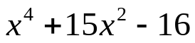

Find all zeroes
2.



whs.saba.do

“It is never too late to be what you might have been.”
- G. Eliot

