Mr. Sabado, Math 3 Week 11 Thursday, November 2, 2017

Homework

Due Today:
- Assignment #44
Factoring by Grouping and Quadratic Form

Due 11/3:
- Assignment #45
Quiz Review

Quiz on Friday (11/3)


Agenda

- Warm-Up

- Lesson Review: Factoring Polynomials

- Class Work

- Homework

- Exit Ticket

Warm-Up

Factor Completely
- 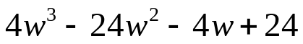

Multiply
- 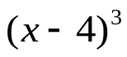


whs.saba.do

“It is never too late to be what you might have been.”
- G. Eliot

