Mr. Sabado, Math 3 Week 15 Monday, November 27, 2017

Homework

Due Today:
- Assignment #57
Writing Equations

Due 12/4:
- Group Project
What Size Box?

Unit 3 Test (12/1)!!!!


Agenda

- Warm-Up

- Group Project: What Size Box?

- Class Work

- Return Graded Work

Warm-Up

Factor the polynomial completely
- 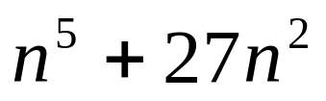

Perform the indicated operation
- 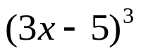


whs.saba.do

“It is never too late to be what you might have been.”
- G. Eliot

