Mr. Sabado, Math 3 Week 11 Friday, November 3, 2017

Homework

Due Today:
- Assignment #45
Quiz Review

Due 11/6:
- Assignment #46
Factoring Practice

Quiz on Friday (11/3)


Agenda

- Warm-Up

- Turn in Opener Packet

- Quiz: Factoring Polynomials

- Homework

Warm-Up

Factor each polynomial completely

- 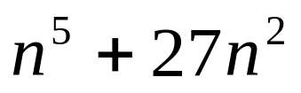

- 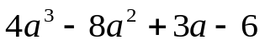


whs.saba.do

“It is never too late to be what you might have been.”
- G. Eliot

