5Mr. Sabado, Math 3 Week 12 Monday, November 6, 2017

Homework

Due Today:
- Assignment #46
Factoring Practice

Due 11/7:
- Assignment #47
Factoring Practice

Quiz on Thursday (11/9)


Agenda

- Warm-Up

- Lesson: Polynomial Division

- Class Work

- Homework

- Return Quizzes: Factoring Polynomials

Warm-Up

Factor
- 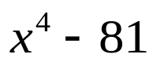

Factor
- 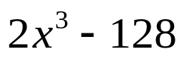


whs.saba.do

“It is never too late to be what you might have been.”
- G. Eliot

