Mr. Sabado, Math 3 Week 17 Monday, December 11, 2017

Homework

Due Today:
- Assignment #65
Graphing Rational Functions Practice

Due 12/12:
- Assignment #66
Rational Expressions +/- Worksheet

Marble Slides Class Code: NHUYR

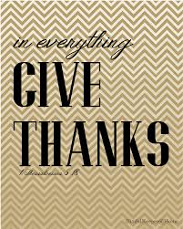

Agenda

- Warm-Up

- Lesson: Add & Subtract Rational Expressions

- Class Work

- Homework

- Return Graded Work

Warm-Up

Simplify

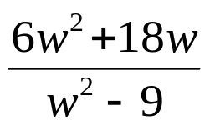

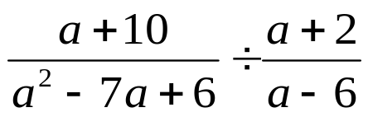

whs.saba.do

“It is never too late to be what you might have been.”
- G. Eliot

