Mr. Sabado, Math 3 Week 17 Wednesday, December 13, 2017

Homework

Due Today:
- Assignment #67
Quiz Review Worksheet

Due 12/14:
- Assignment #67
Rational Review Worksheet

Quiz on Wednesday!!! (12/13)
Marble Slides Class Code: NHUYR



Agenda

- Warm-Up
- HW Questions

- Quiz: Rational Functions

- Homework

- Return Graded Work

Warm-Up

Simplify

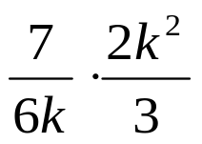

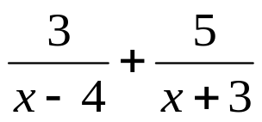

whs.saba.do

“It is never too late to be what you might have been.”
- G. Eliot

