Mr. Sabado, Math 3 Week 17 Thursday, December 14, 2017

Homework

Due Today:
- Assignment #68
Rational Review Worksheet

Due 12/15:
- Assignment #69
Complex Fractions

Marble Slides Class Code: NHUYR



Agenda

- Warm-Up

- Lesson: Complex Fractions

- Error Analysis

- Homework

- Return Graded Work

Warm-Up

Simplify

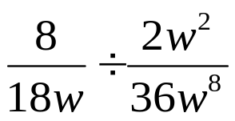

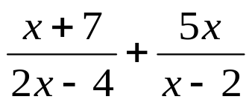

whs.saba.do

“It is never too late to be what you might have been.”
- G. Eliot

