Mr. Sabado, Math 3 Week 16 Tuesday, December 5, 2017

Homework

Due Today:
- - Assignment #61
Cost of a Zero

Due 12/6:
- Assignment #62
Graphing Rational Functions

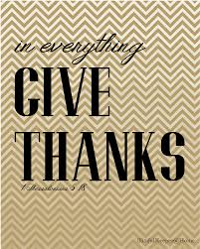

Agenda

- Warm-Up

- Discovery Lesson: Rational Functions

- Class Work

- Homework

- Return Graded Work

Warm-Up

- Graph the Parent Function 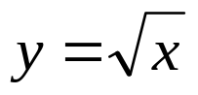

- Graph the function 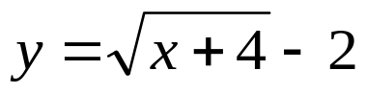 by translating.


whs.saba.do

“It is never too late to be what you might have been.”
- G. Eliot

