Mr. Sabado, Math 3 Week 16 Wednesday, December 6, 2017

Homework

Due Today:
- Assignment #62
Graphing Rational Functions

Due 12/7:
- Assignment #63
Graphing General Rational Functions

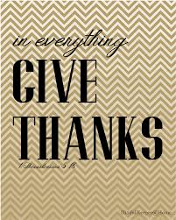

Agenda

- Warm-Up

- Guided Practice: Equivalent forms of Functions

- Class Work

- Homework

- Return Graded Work

Warm-Up

- Graph the Parent Function 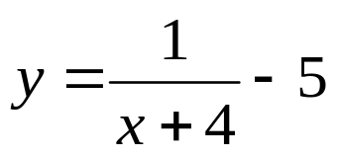

- Determine the end behavior of #1.

- Determine the domain and range.


whs.saba.do

“It is never too late to be what you might have been.”
- G. Eliot

