Mr. Sabado, Math 3 Week 16 Thursday, December 7, 2017

Homework

Due Today:
- Assignment #63
Graphing General Rational Functions

Due 12/8:
- Assignment #64
Graphing Rational Functions Practice
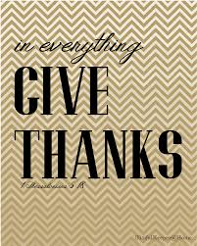

Agenda

- Warm-Up
- HW Questions

- Class Work: Desmos Activity
Class Code: NHUYR

- Homework

- Return Graded Work

Warm-Up

- Graph the Function 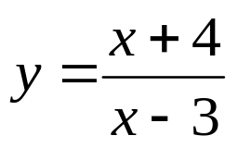

- Determine the end behavior of #1.

- Determine the domain and range.


whs.saba.do

“It is never too late to be what you might have been.”
- G. Eliot

