Mr. Sabado, Math 3 Week 16 Friday, December 8, 2017

Homework

Due Today:
- Assignment #64
Graphing Rational Functions Practice

Due 12/11:
- Assignment #65
Graphing Rational Functions Practice

Marble Slides Class Code: NHUYR



Agenda

- Warm-Up
- Turn in Opener Packet

- Lesson: Multiplying and Dividing Rational Functions

- Class Work
- Homework

- Return Graded Work

Warm-Up

Write an equivalent equation
- 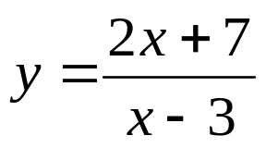
- 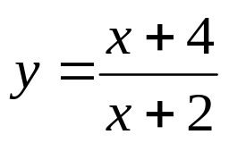
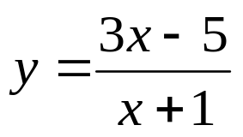

whs.saba.do

“It is never too late to be what you might have been.”
- G. Eliot

