Mr. Sabado, Math 3 Week 4 Monday, September 11, 2017

Homework

Due Today:
- Assignment #10
Function Families: Add Domain, Range, x & y int., End Behavior

Due 9/12:
- Assignment #11
Intervals of +/- & Increase/Decrease

Agenda

- Warm-Up

- Notes: Intervals of +/- Values and Increase/Decrease

- Class Work

- Homework

- Return Graded Work

- Practice Dismissal

Warm-Up

Simplify the Expression

- 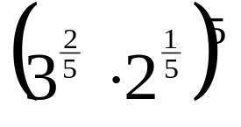

Solve
- 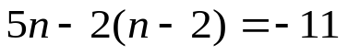
Solve for s.
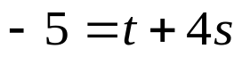

whs.saba.do



“It is never too late to be what you might have been.”
- G. Eliot

