Mr. Sabado, Math 3 Week 5 Monday, September 18, 2017

Homework

Due Today:
- Assignment #15
Spiral Review #2

Due 9/15:
- Assignment #16
Inverse Functions

Unit 1 Test on Tuesday!!!

Agenda

- Warm-Up

- Lesson: Functions

- Class Work

- Homework

- Return Graded Work

- Practice Dismissal

Warm-Up

f(x)=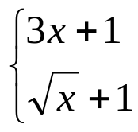 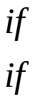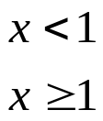
Evaluate
- f(25)
- f(1)
- f(-2)

whs.saba.do



“It is never too late to be what you might have been.”
- G. Eliot

