Mr. Sabado, Math 3 Week 6 Wednesday, September 27, 2017

Homework

Due Today:
No HW

Due 9/28:
- Assignment #22
Solving Equations

Agenda

- Warm-Up

- Review: Solving Equations and Inequalities

- Class Work

- Homework

Warm-Up

Solve the Following

1. -4(3k + 5) = -2(5 – k)

- 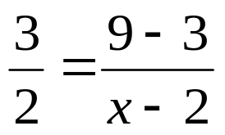

whs.saba.do

“It is never too late to be what you might have been.”
- G. Eliot

