Mr. Sabado, Math 3 Week 6 Monday, September 28, 2017

Homework

Due Today:
- Assignment #22
Solving Equations (white)

Due 9/29:
- Assignment #23
Solving Equations
(gold)

Agenda

- Warm-Up

- Review: Solving Equations (white)

- Class Work (green)
- Homework (gold)
- 

Warm-Up

Solve the Following

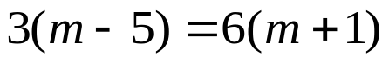
- 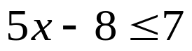

whs.saba.do

“It is never too late to be what you might have been.”
- G. Eliot

