Mr. Sabado, Math 3 Week 6 Friday, September 29, 2017

Homework

Due Today:
- Assignment #23
Solving Equations
(gold)

Due 10/2:
- Assignment #24
Choose Your Method

Quiz on Thursday 10/5!!!

Agenda

- Warm-Up
- Turn in Opener Packet

- Notes: Solving Quadratic Equations

- Group Class Work
- Homework
- 

Warm-Up

Factor
1. 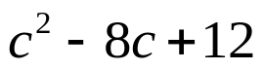

2. 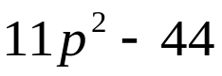

whs.saba.do

“It is never too late to be what you might have been.”
- G. Eliot

