Mr. Sabado, Math 3 Week 3 Thursday, September 7, 2017

Homework

Due Today:
- Assignment #8
Writing Functions

Due 9/8:
- Assignment #9
Function Families

Agenda

- Warm-Up

- Notes: Parent Functions Continued

- Classwork

- Homework

- Return Graded Work

- Practice Dismissal

Warm-Up

Solve the Following

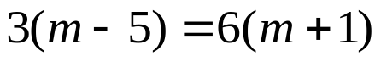
Isolate for y
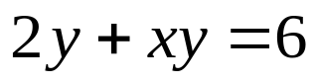

whs.saba.do



“It is never too late to be what you might have been.”
- G. Eliot

