Mr. Sabado, Algebra 2 Week 8 Thursday, October 15, 2015

Homework
Due Today:
- Assignment #33
p. 432: (3-37 odd, 36, 44, 48-53)

Due 10/16:
- Assignment #34
p. 442: (3-13, 29, 31, 32, 34, 36)

Unit 2 Test:
10/20: Calculator
10/21: No Calculator

Agenda

- Warm-Up

- Lesson: Inverse Functions

- Class Work

- Homework

- Return Graded Work


Warm-Up

Let f(x) = 3x and g(x) = x + 3

- 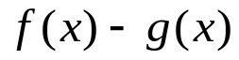

- 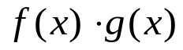

- 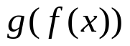
Solve
- 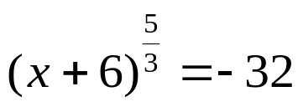

Algebra 2 Online Textbook: 2606518-10
classzone.com

whs.saba.do

yes

“It is never too late to be what you might have been.”
- G. Eliot

