Mr. Sabado, Algebra 2 Week 9 Monday, October 19, 2015

Homework
Due Today:
- Assignment #35
Inverse Functions Practice

Due 10/20:
- Assignment #36
Unit 2 Review #1
- Assignment #37
Unit 2 Review #2

Unit 2 Test:
10/20: Calculator
10/21: No Calculator

Agenda

- Opener Sheet Warm-Up

- Unit 2 Test Review:

- Class Work

- Homework

- Return Graded Work


Warm-Up

Let g(x) = 5x - 6 and h(x) = 3x²
- 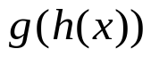

- 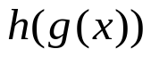

- 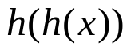
Find the inverse of
- 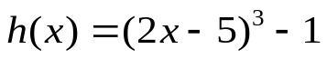

Algebra 2 Online Textbook: 2606518-10
classzone.com

whs.saba.do

yes

“It is never too late to be what you might have been.”
- G. Eliot

