Mr. Sabado, Algebra 1 Week 18 Monday, January 12, 2015

Homework

Due Today:
Extra Credit:
Word Search

Due 1/13:
Assignment #69:
Page 159 #1-15

Quiz on Friday!!!

Agenda

- Opener Sheet
- Warm-Up

- Return Quiz: One-Step Inequalities

- Lesson: Solving Two Step Inequalities

- Class Work

- Return Graded Work

Warm-Up

Solve

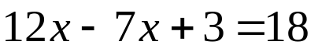

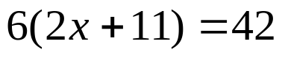

Simplify
3) 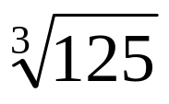

`whs.saba.do

“It is never too late to be what you might have been.”
- G. Eliot

