Mr. Sabado, Algebra 1 Week 18 Tuesday, January 13, 2015

Homework

Due Today:
Assignment #69:
Page 159 #1-15

Due 1/14:
Assignment #70:
Page 159 #16-36

Quiz on Friday!!!

Agenda

- Warm-Up
- HW Questions

- Lesson Continued: Solving Two Step Inequalities

- Class Work

- Return Graded Work

Warm-Up

Solve
1.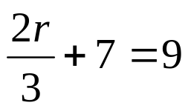

2.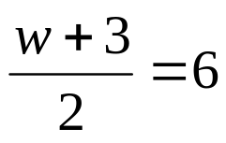

Simplify
3) 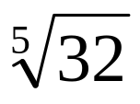
`whs.saba.do

“It is never too late to be what you might have been.”
- G. Eliot

