Mr. Sabado, Algebra 1 Week 18 Wednesday, January 14, 2015

Homework

Due Today:
Assignment #70:
Page 159 #16-36

Due 1/15:
Assignment #71:
Page 164 #1-11

Quiz on Friday!!!

Agenda

- Warm-Up
- HW Questions

- Lesson: Solving Inequalities w/ Variables on Both Sides

- Class Work

- Return Graded Work

Warm-Up

Solve
1.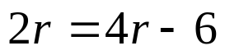

2.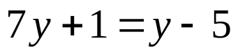

3) 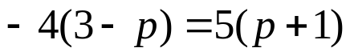
`whs.saba.do

“It is never too late to be what you might have been.”
- G. Eliot

