Mr. Sabado, Algebra 1 Week 18 Thursday, January 15, 2015

Homework

Due Today:
Assignment #71:
Page 164 #1-11

Due 1/16:
Assignment #72:
Quiz Review Worksheet

Quiz on Friday!!!

Agenda

- Warm-Up
- HW Questions

- Lesson Continued: Solving Inequalities w/ Variables on Both Sides

- Class Work

- Homework

- Return Graded Work

Warm-Up

Solve
1.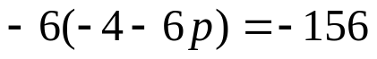

2.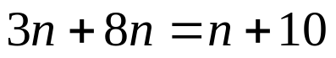


`whs.saba.do

“It is never too late to be what you might have been.”
- G. Eliot

