Mr. Sabado, Algebra 1 Week 18 Friday, January 16, 2015

Homework

Due Today:
Assignment #72:
Quiz Review Worksheet
Opener Packet

Due 1/20:
Extra Credit

Quiz on Friday!!!

Agenda

- Warm-Up
- HW Questions
- Turn in Packets

- Quiz: Solving Inequalities w/ Variables on Both Sides

- Quiet Activity

- Homework

- Return Graded Work

Warm-Up

Solve & Graph
1.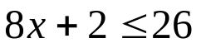

2.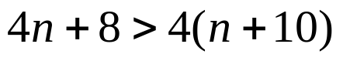

`whs.saba.do

“It is never too late to be what you might have been.”
- G. Eliot

