Mr. Sabado, Algebra 1 Week 19 Tuesday, January 20, 2015

Homework

Due Today:
Extra Credit

Due 1/21:
Assignment #73:
Chapter 3 Study Guide

Chapter 3 Unit Test on Wednesday!!!

Agenda

- Opener Sheet
- Warm-Up

- Test Review: Solving Inequalities

- Class Work

- Homework

- Return Graded Work

Warm-Up

Solve & Graph
1.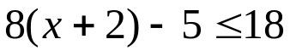

2.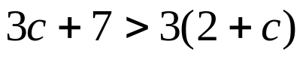

`whs.saba.do

“It is never too late to be what you might have been.”
- G. Eliot

