Mr. Sabado, Algebra 1 Week 17 Wednesday, January 7, 2015

Homework

Due Today:
Assignment #66:
Page 151: 1-17

Due 1/8:
Assignment #67:
Page 151: 19-41 odd, 84-87

Quiz on Friday!!!


Agenda

- Warm-Up
- HW Questions

- Lesson Continued: One-Step Inequalities

- Class Work

- Homework
- Return Graded Work

Warm-Up

Solve and graph the following
- 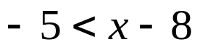

- 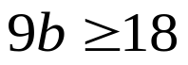

- 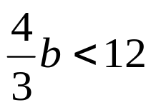

`whs.saba.do

“It is never too late to be what you might have been.”
- G. Eliot

