Mr. Sabado, Algebra 1 Week 17 Thursday, January 8, 2015

Homework

Due Today:
Assignment #67:
Page 151: 19-41 odd, 84-87

Due 1/9:
Assignment #68:
Quiz Review Worksheet

Quiz on Friday!!!


Agenda

- Warm-Up
- HW Questions

- Review One-Step Inequalities

- Class Work

- Homework
- Return Graded Work

Warm-Up

Solve the proportion
1. 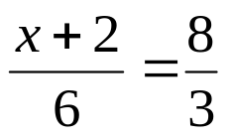

2. What is 93% of 200?

3. 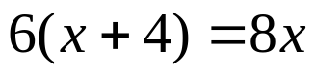

`whs.saba.do

“It is never too late to be what you might have been.”
- G. Eliot

