Mr. Sabado, Algebra 1 Week 17 Friday, January 9, 2015

Homework

Due Today:
Assignment #68:
Quiz Review Worksheet

Due 1/12:
Word Search

Quiz on Friday!!!


Agenda

- Warm-Up
- HW Questions
- Turn in Packet

- Review: One-Step Inequalities

- Quiz

- Quiet Activity

- Return Graded Work

Warm-Up

Solve then graph
- 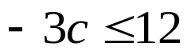
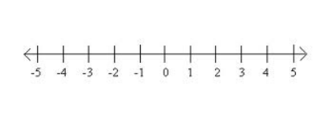
Simplify
- 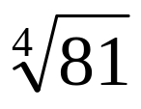

- 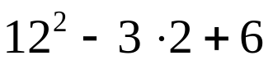

`whs.saba.do

“It is never too late to be what you might have been.”
- G. Eliot

