Mr. Sabado, Algebra 2 Week 18 Monday, January 12, 2015

Homework

Due Today:
- Assignment #65
Review Worksheet 5.5 & 5.6

Due 1/13:
- Assignment #66
Page 383: 3-13 odd, 14, 19
Quiz on Friday!!!

Agenda

- Opener Sheet
- Warm-Up

- Error Analysis of Quiz: Factoring Polynomials and Rational Zeroes

- Discovery Lesson: Fundamental Theorem of Algebra

- Return Graded Work

Warm-Up

Factor
- 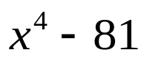

Factor
- 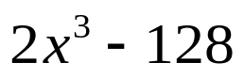

`whs.saba.do


“It is never too late to be what you might have been.”
- G. Eliot

