Mr. Sabado, Algebra 2 Week 18 Wednesday, January 14, 2015

Homework

Due Today:
- Assignment #66
Page 383: 3-13 odd, 14, 19

Due 1/15:
- Assignment #67
Page 384: 22-24, 27-29, 32

Unit 4 Test Next Wednesday!!!

Agenda

- Warm-Up
- HW Questions

- Lesson: Writing Polynomial Functions & End Behavior

- Class Work

- Return Graded Work

Warm-Up

Multiply

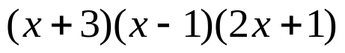

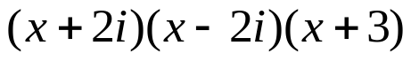

`whs.saba.do


“It is never too late to be what you might have been.”
- G. Eliot

