Mr. Sabado, Algebra 2 Week 18 Thursday, January 15, 2015

Homework

Due Today:
- Assignment #67
Page 384: 22-24, 27-29, 32

Due 1/16:
- Assignment #68
Graphing Polynomials Worksheet

Unit 4 Test Wednesday!!!

Agenda

- Warm-Up
- HW Questions

- Lesson: End Behavior

- Class Work

- Homework

- Return Graded Work

Warm-Up

Write a polynomial function with the following zeros:
- 3, 2, -3

- -1, 3 – 2i

`whs.saba.do

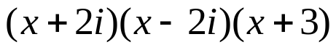

“It is never too late to be what you might have been.”
- G. Eliot

