Mr. Sabado, Algebra 2 Week 18 Friday, January 16, 2015

Homework

Due Today:
- Assignment #68
Graphing Polynomials Worksheet

Due 1/20:
- Assignment #69
Polynomial Unit Review Worksheet

Unit 4 Test Wednesday!!!

Agenda

- Warm-Up
- HW Questions
- Turn in Packet

- Class Work: Exploring Graphs of Polynomial Functions

- Homework

- Return Graded Work

Warm-Up

Factor each polynomial completely
- 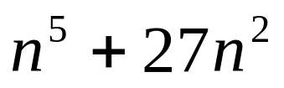

- 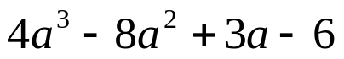

`whs.saba.do

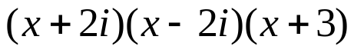

“It is never too late to be what you might have been.”
- G. Eliot

