Mr. Sabado, Algebra 2 Week 19 Tuesday, January 20, 2015

Homework

Due Today:
- Assignment #69
Polynomial Unit Review Worksheet

Due 1/21:
- Assignment #70
Graphing Polynomial Review Worksheet #1-10

Unit 4 Test Wednesday!!!
Scientific Calculator ONLY!!!

Agenda

- Warm-Up
- HW Questions

- Class Work: Polynomial Review

- Homework (key will be posted tonight)

- Return Graded Work

Warm-Up

Factor each polynomial completely
- 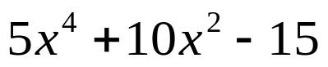
Solve:
- 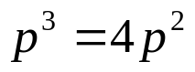

`whs.saba.do

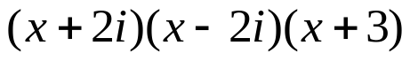

“It is never too late to be what you might have been.”
- G. Eliot

