Mr. Sabado, Algebra 2 Week 17 Wednesday, January 7, 2015

Homework

Due Today:
- Assignment #62
p. 366: 3-10, 37, 51-60

Due 1/8:
- Assignment #63
p. 366: 11-19 odd, 20, 27-32

Quiz on Friday!!!


Agenda

- Warm-Up
- HW Questions

- Lesson: Remainder Theorem – Part 2

- Class Work

- Homework

- Return Graded Work

Warm-Up

Divide

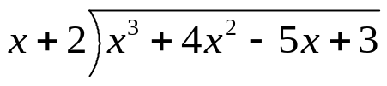

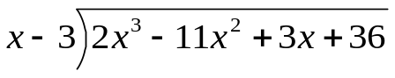

`whs.saba.do


“It is never too late to be what you might have been.”
- G. Eliot

