Mr. Sabado, Algebra 2 Week 17 Thursday, January 8, 2015

Homework

Due Today:
- Assignment #63
p. 366: 11-19 odd, 20, 27-32

Due 1/9:
- Assignment #64
p. 366: 11-19 odd, 20, 27-32

Quiz on Friday!!!


Agenda

- Warm-Up
- HW Questions

- Lesson: Remainder Theorem – Part 2

- Class Work

- Homework

- Return Graded Work

Warm-Up

Divide

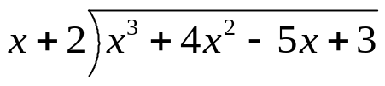

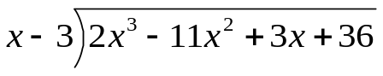

`whs.saba.do


“It is never too late to be what you might have been.”
- G. Eliot

