Mr. Sabado, Algebra 2 Week 17 Friday, January 9, 2015

Homework

Due Today:
- Assignment #64
p. 374: 3-17

Due 1/12:
- Assignment #65
Review Worksheet 5.5 & 5.6

Quiz on Friday!!!


Agenda

- Warm-Up
- HW Questions
- Turn in Opener Packet

- Quiz: Factoring Polynomials and Rational Zeroes

- Homework

- Return Graded Work

Warm-Up

List the possible rational zeros
1. 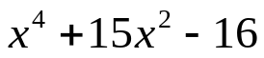

Find all real zeros
2.

`whs.saba.do


“It is never too late to be what you might have been.”
- G. Eliot

