Mr. Sabado, Algebra 1 Week 17 Tuesday, January 6, 2015

Homework

Due Today:
Assignment #65:
Solving Inequalities Worksheet Review

Due 1/7:
Assignment #66:
Page 151: 1-17

Quiz on Friday!!!


Agenda

- Warm-Up
- HW Questions

- Lesson: One-Step Inequalities

- Class Work

- Homework
- Return Graded Work

Warm-Up

Graph the following
- 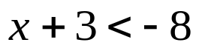

Solve
- 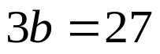
- 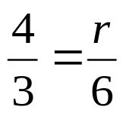

`whs.saba.do

“It is never too late to be what you might have been.”
- G. Eliot

