Mr. Sabado, Algebra 2 Week 17 Tuesday, January 6, 2015

Homework

Due Today:
- Assignment #61
Factoring Review: What is the Title of this Picture?

Due 1/7:
- Assignment #62
p. 366: 3-10, 37, 51-60
Quiz on Friday!!!


Agenda

- Warm-Up

- Lesson: Remainder Theorem – Part 1

- Class Work:

- Homework

- Return Graded Work

Warm-Up

Divide without a calculator. Show all work.

- 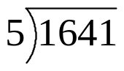

- 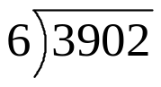

`whs.saba.do


“It is never too late to be what you might have been.”
- G. Eliot

