Mr. Sabado, Algebra 1 Week 2 Friday, February 13, 2015

Home Practice

Due Today:
Assignment #7:
Relations and Functions Worksheet (Practice C)

Due 2/17:
Extra Credit
Energy Saver

Quiz Today!!!



Agenda

- Warm-Up
- Turn in Packet

- Quiz: Order of Operations, Fractions, Distributive Property, Functions

- Quiet Activity:
- Homework


Warm-Up

Simplify the following when w = 4 and z = 2
- 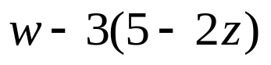
- 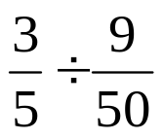

`whs.saba.do

“It is never too late to be what you might have been.”
- G. Eliot

